# Download Exiobase v3.3.16 for SimaPro

### 1) Download the zipfile:

<https://www.dropbox.com/s/mg8ez6lj9i1zkmh/2020%20EXIOBASE3316b1%26b2_20200904_re-structured.zip?dl=0>

### 2) Unzip the file

Unzip and save the files somewhere on your harddrive.

### 3) Open the database from SimaPro

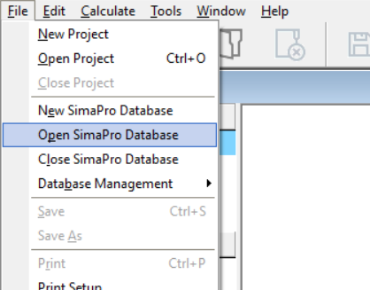

### 4) Browse to the location, where you have extracted the zip-file

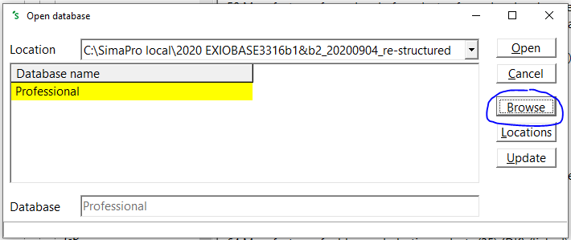

### 5) Create a new project

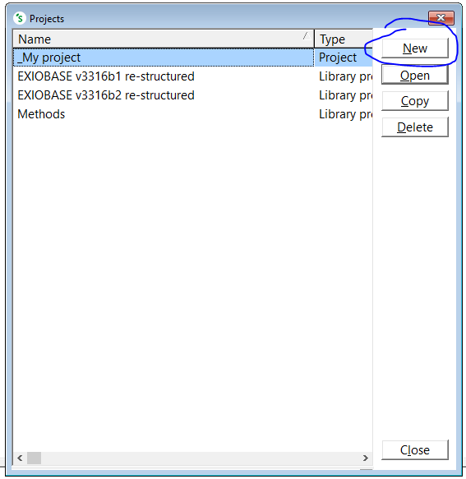

### 6) Select the EXIOBASE b2 and the Methods libraries

